ASM LABSHEET 5

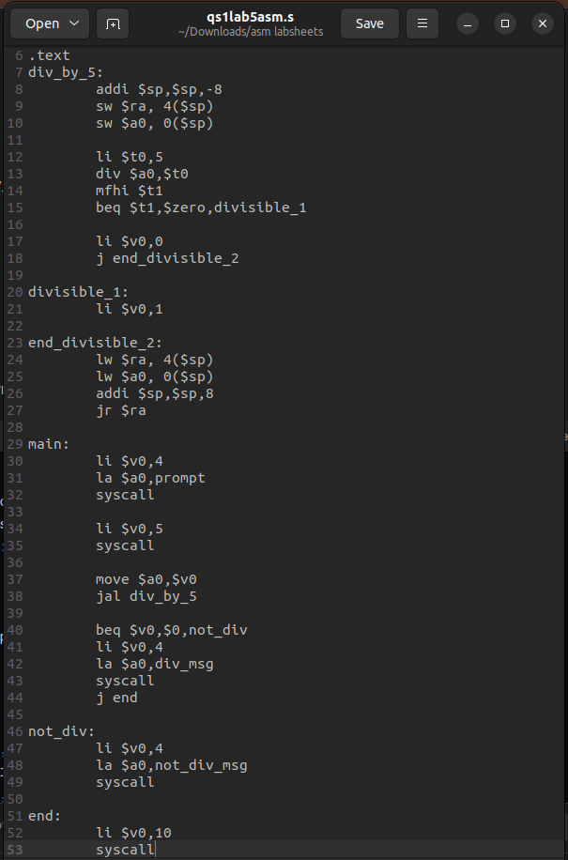
1. Write the MIPS code(using stack) to read a number and check if it is divisible by 5 (pass arguments and display the result according to the return value).
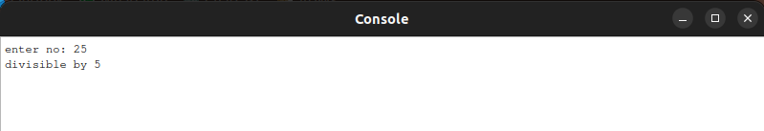
2. Write the MIPS code to find the factorial of a given number(using stack)

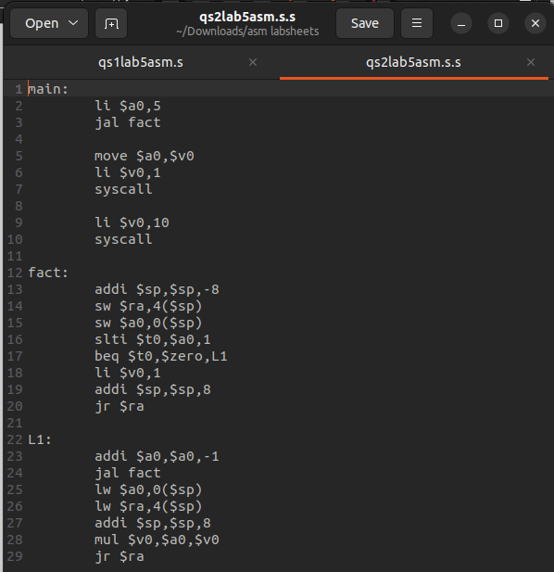
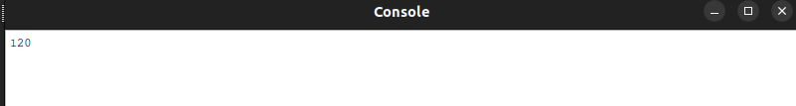

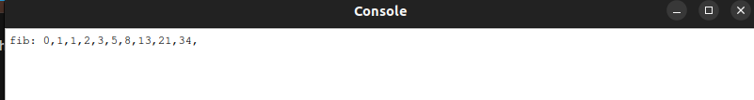
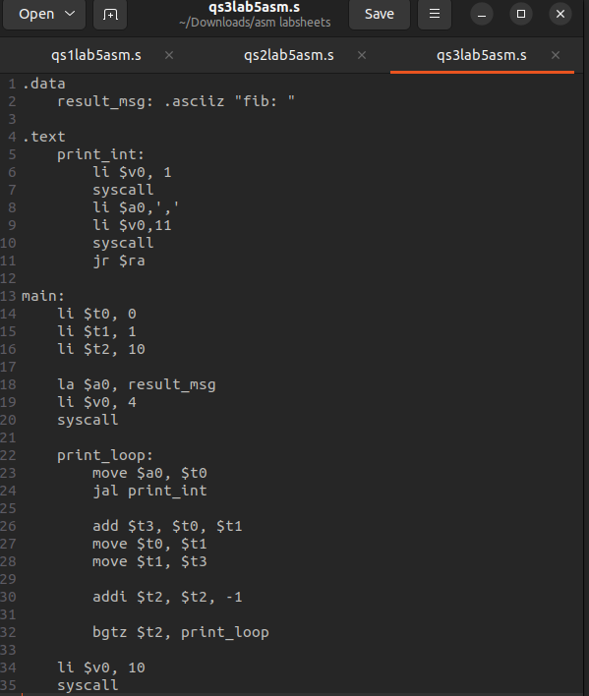
3. Write the MIPS code to display the Fibonacci series having n terms (n is read from user)
4. Write the MIPS code to display the Fibonacci series having n terms (n is read from user)using stack.
